**Name:**  **Session:**

**Programming II**

**Lab Exercise 5.5.2020**

**Making a Drawing Program**

In this lab exercise you will build a simple drawing program. I will give you the basic code for the various functionalities of the program then I encourage you to improve the program. For this program, I used a form that had dimensions of 1290 x 766.

**The Interface**

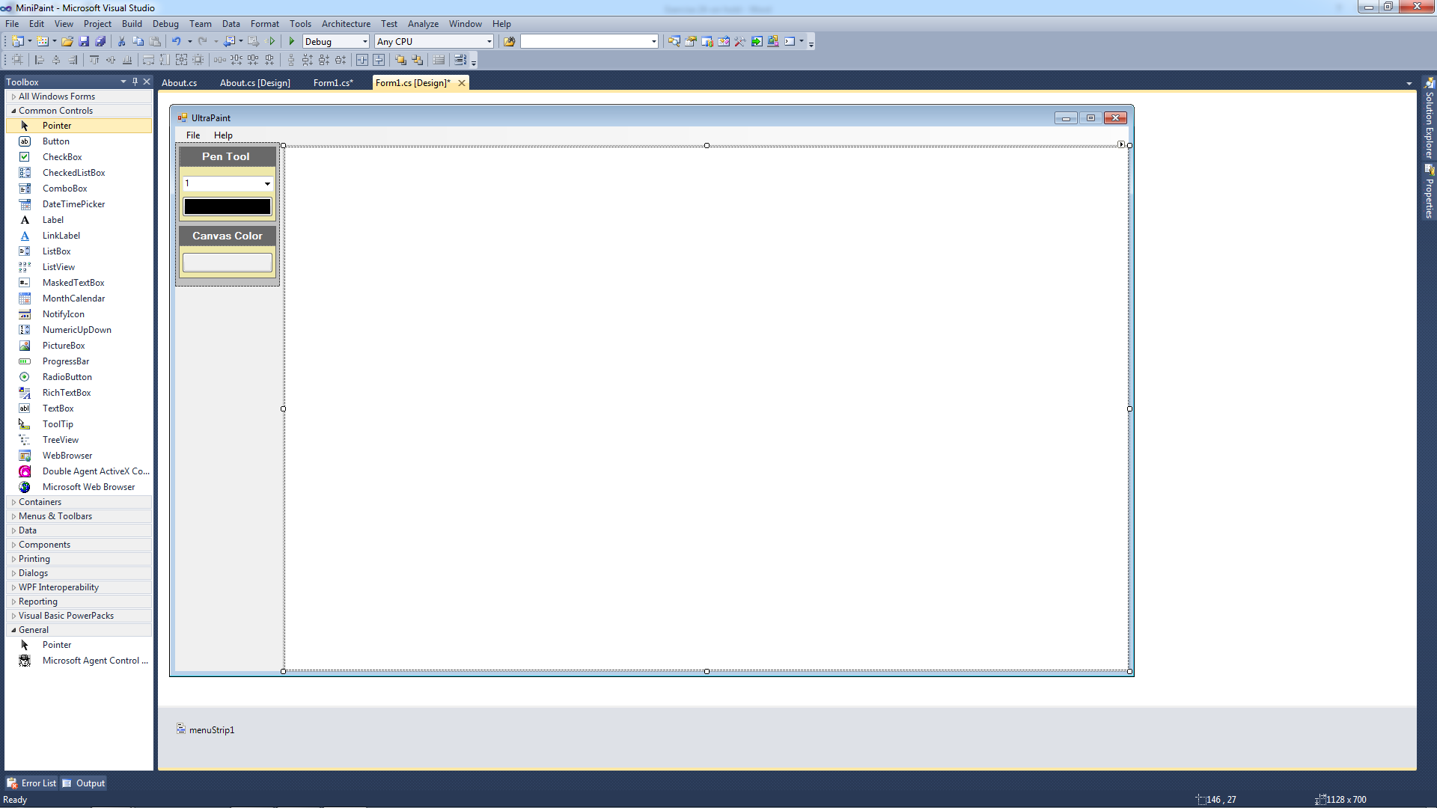

On this form you will need the following Controls.

btnPenColor – allows selection of Pen Color as well as shows the color

btnCanvasColor – allows selection of Canvas Color as well as shows the color

pnlPenTool – purely cosmetic

pnlCanvasColor – purely cosmetic

cboPenSize – Allows selection of Pen width

pbDraw – used to hold graphics object

Menu Structure

File About

New About UltraPaint

Save

Open

Exit

After you have completed your interface, it is time to write the code.

1. Start by declaring some variables global to the form. Note the nullable integer variables (see handout on nullable variables):

//Declare global variables

bool startPaint = false;

Graphics g;

Bitmap bmp;

//nullable int variables capable storing null value

int? initX = null;

int? initY = null;

1. Add the following code to the constructor:

//Create graphics object at same location as pbDraw

g = pbDraw.CreateGraphics();

//Create Bitmap object same size as as pbDraw

bmp = new Bitmap(pbDraw.Width, pbDraw.Height);

//Associate bitmap object with picturebox

pbDraw.Image = bmp;

1. Add the following code to the btnPenColor_Click event handler

//Open Color Dialog and Set BackColor of btnPenColor if user click on OK

ColorDialog c = new ColorDialog();

if (c.ShowDialog() == DialogResult.OK)

{

btnPenColor.BackColor = c.Color;

}

1. Add the following code to the btnCanvasColor_Click event handler

ColorDialog c = new ColorDialog();

if (c.ShowDialog() == DialogResult.OK)

{

//Color all pixels in the bitmap with background color

for (int x = 0; x < bmp.Width; x++)

for (int y = 0; y < bmp.Height; y++)

bmp.SetPixel(x, y, c.Color);

pbDraw.BackColor = c.Color;

btnCanvasColor.BackColor = c.Color;

}

1. Add the following code to the pbDraw_MouseDown event handler

startPaint = true;

1. Add the following code to the pbDraw_MouseMove event handler:

if (startPaint)

{

//Setting the Pen BackColor and line Width

Pen p = new Pen(btnPenColor.BackColor, float.Parse(cboPenSize.Text));

//Associate graphics object to bitmap

g = Graphics.FromImage(bmp);

//Drawing the line.

g.DrawLine(p, new Point(initX ?? e.X, initY ?? e.Y), new Point(e.X, e.Y));

//Copy bitmap to picturebox

pbDraw.Image = bmp;

//set beginning point for next line

initX = e.X;

initY = e.Y;

}

1. Add the following code to the pbDraw_MouseUp event handler:

startPaint = false;

initX = null;

initY = null;

1. Add the following code to the newToolStripMenu_Click event handler:

g.Clear(pbDraw.BackColor);

g = Graphics.FromImage(bmp);

pbDraw.BackColor = Color.White;

btnCanvasColor.BackColor = Color.White;

for (int x = 0; x < bmp.Width; x++)

for (int y = 0; y < bmp.Height; y++)

bmp.SetPixel(x, y, Color.White);

pbDraw.Image = bmp;

1. Add the following code to the saveToolStripMenu_Click event handler:

SaveFileDialog save = new SaveFileDialog();

save.Filter = "BMPfiles|*.bmp";

if (save.ShowDialog() == DialogResult.OK)

{

pbDraw.Image.Save(save.FileName);

}

1. Add the following code to the openToolStripMenu_Click event handler:

OpenFileDialog open = new OpenFileDialog();

open.Filter = "BMPfiles|*.bmp";

if (open.ShowDialog() == DialogResult.OK)

{

Bitmap newImage = new Bitmap(open.FileName);

bmp = newImage;

pbDraw.Image = bmp;

}

1. Add the following code to the exitToolStripMenu_Click event handler:

if (MessageBox.Show("Do you want to Exit?", "Exit", MessageBoxButtons.YesNo,

MessageBoxIcon.Information) == DialogResult.Yes)

{

Application.Exit();

}

1. Add the following code to the aboutUltraPaintToolStripMenu_Click event handler:

About a = new About();

a.ShowDialog();

**When you have completed your project print a screen shot of a painting you make and turn it in attached to this sheet.**